VEGETABLES

PEPPER:
- BIG BERTHA
- LADY BELL
- HABANERO RED
- HOT BANANA
- ITALIAN FRYR
- LUNCHBOX MIX
- CAJUN BELLE
- CHERRY BOMB
- PEPPERONCINI
- SWEET BANANA
- CAL WONDER
- HABANERO
- JALAPENO
- ANAHEIN
- HUNGARIAN HOT WAX

EGGPLANT: DUSKY

CABBAGE: BRUNSWICK

CELERY: UTAH TALL

BROCCOLI:
- ARCADIA
- DESTINY

BRUSSEL SPROUTS: DARLING

TOMATO:
- CHEROKEE PURPLE
- GRAPE
- RED VELVET (PATIO)
- SUPER SWEET 100'S
- RIPPLE RED
- TUMBLIN TOM YELLOW
- YELLOW PEAR
- LARGE CHERRY
- BEST BOY BUSH
- OXHEART BICOLOR
- GERMAN JOHNSON
- JETSTAR
- HILLBILLY
- BRANDYWINE
- DELICIOUS
- EARLY DOLL
- SUNNY BOY
- SUPER SIOUX
- AMISH PASTE
- ROMA
- RUSSIAN PINK
- WISCONSIN 55
- BEEFSTEAK
- SUPERSONIC
- BIG UGLY PURPLE

CAULIFLOWER: SNOWBALL

HERBS
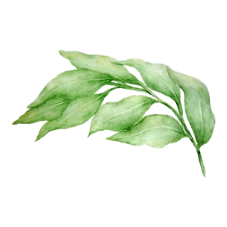
- BASIL
  - GENOVESE
- COMMON SAGE
- LAVENDER
- ROSEMARY
- CILANTRO
- DILL
- THYME
- OREGANO
- PARSLEY
  - FLAT OR CURLY

